Welcome To Heron House

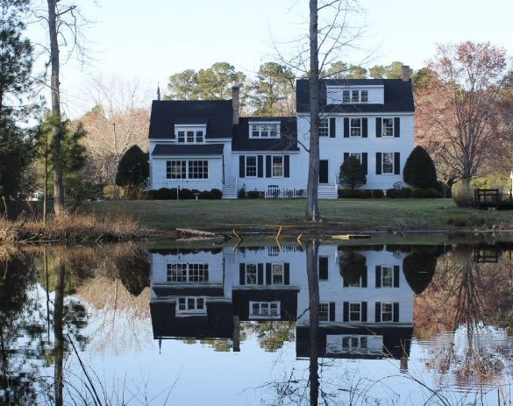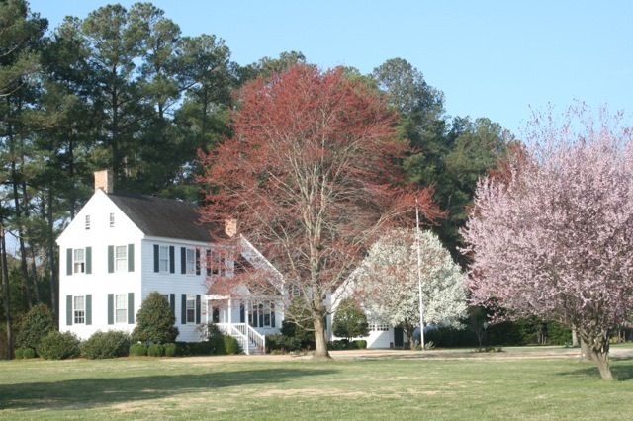

16316 Red Bank Lane
Melfa, Virginia 23410
A contradiction of wonderful. Heron House is an 1846 Eastern Shore Style home. Moved 20 miles from a field near White Rabbit to the creek front subdivision of Red Bank in 1992, then meticulously restored into 3,265 sq. ft. of updated 21st century elegance. It has 420 ft. of waterfront on a 6 acre fresh water pond, perfect for kayaks and birdwatching. An oasis for blue herons, egrets, eagles and songbirds. Your deck is near the water, hidden in the woods is your Caribbean shack, and perched on the pond you’ll hang out in every day. Trust us. Lots of privacy on 3 acres. THEN stroll to the community dock, w/ 4’ MLW. Be out the creek and fishing on the bay in minutes. Plus just 4 miles to the charms of Onancock. Absolutely so much more than you expect. The best of both worlds for the price of one.

In 1992 Heron House was moved about twenty miles to the historic neighborhood of Redbank from a field. Here are some moving pictures.
There are more. Quite the project.

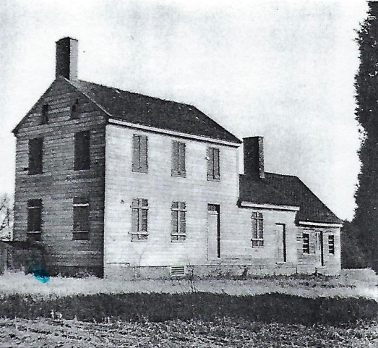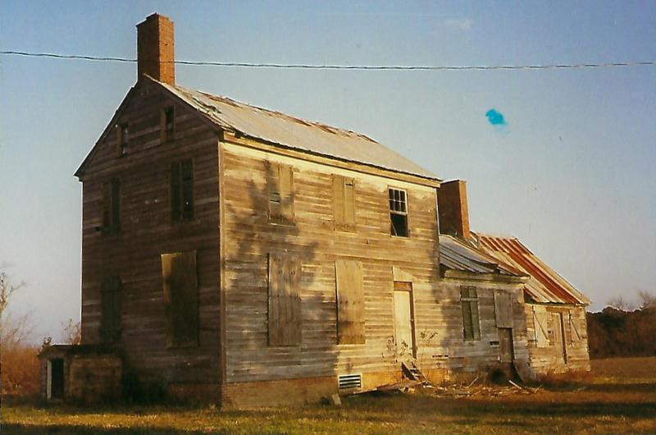

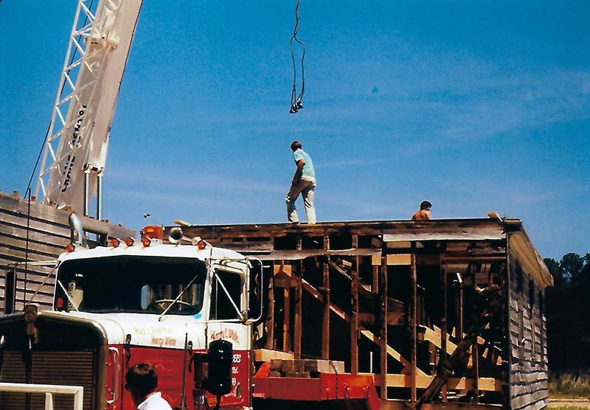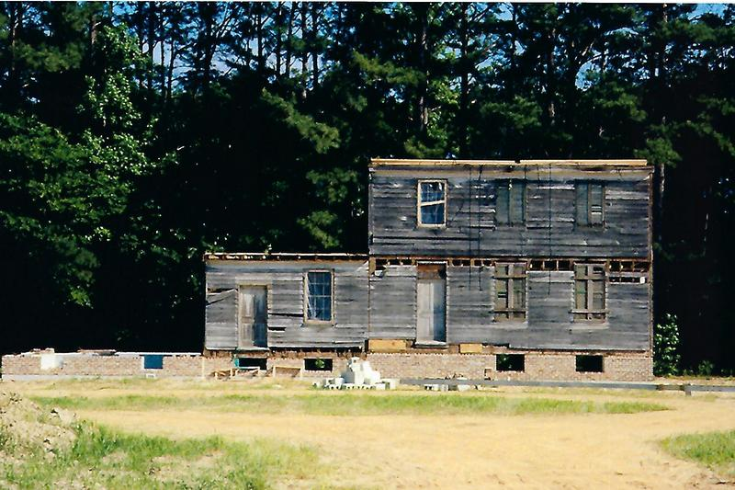

M

Historic Home on the Water in Redbank

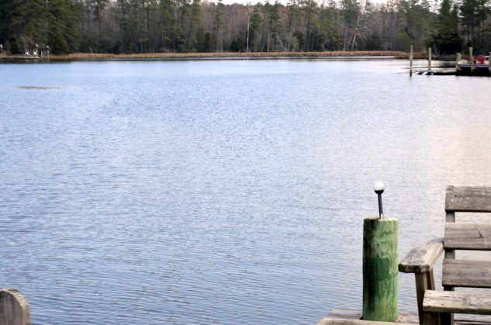

Red Bank is a small 30 lot subdivision 4 miles and 10 minutes from Onancock.

The name Red Bank first recorded in an 1805 deed was probably derived from the reddish clay soil that is found in the soil of the high bank which runs along the creek shore.

It is on a peninsula on the bayside in the central part of Virginia’s Eastern Shore. Bounded on the north and west sides by the main branch of Pungoteague Creek (a tributary of the Chesapeake Bay) and on the south by a six acre, fresh water pond.

Throughout Eastern Shore history, the Pungoteague Creek waterway was an important avenue for transporting supplies and military personnel. It has the deepest natural channel of any Eastern Shore bayside creek and was the creek in Accomack County to have scheduled passenger steamer service.

DETAILS THAT IMPRESS:
3 original fireplaces—one gas, 2 wood burning,
Classic Eastern Shore center hallway with two doors to catch the breeze
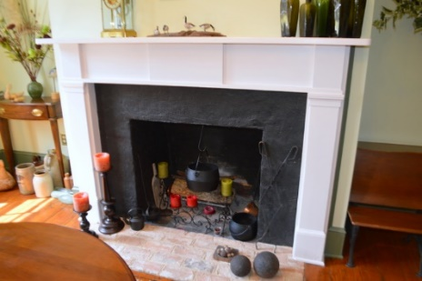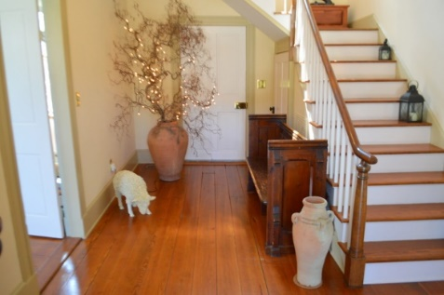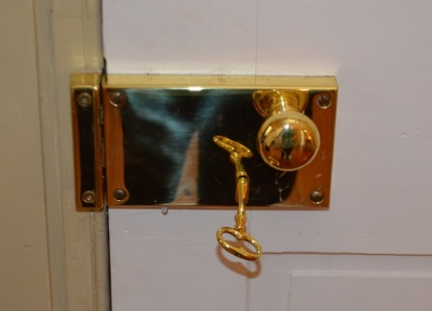
Almost all original windows
Original pine floors
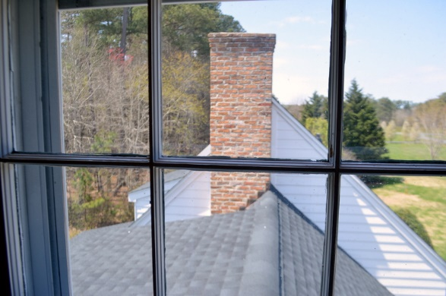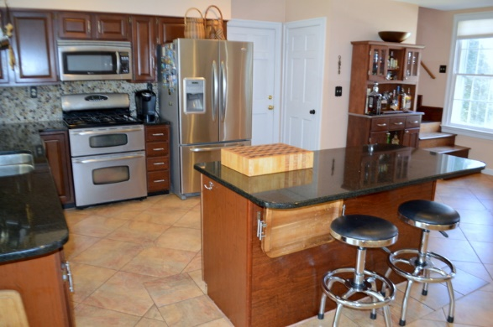
Large cook’s kitchen with granite counters
Breakfast Island AND room for a table
Maytag kitchen appliances
Sunroom that’s perfect for birdwatching and goofing off. You will do more of that here on the shore.
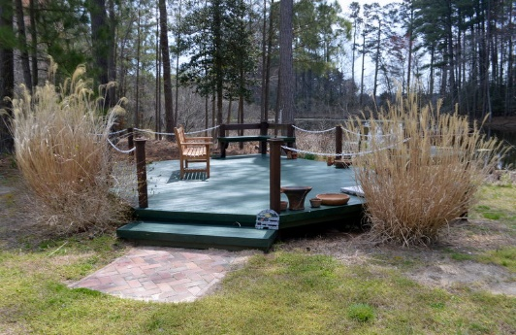
Should you feel the need for a downstairs bedroom we have a suggestion. Just ask. Of course those intrepid folks in the 1840’s would be shocked at us for even thinking of such a thing.
Ingenious garage storage and laid out for easy convert to upstairs apartment. Brick lined driveway.
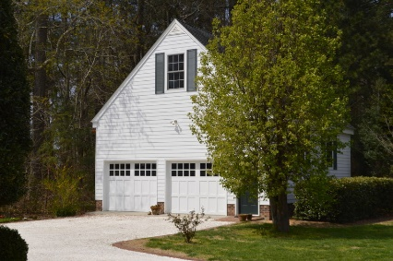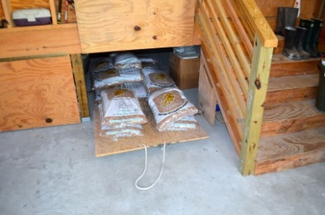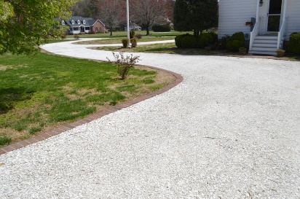
Extensive Landscaping on Three Acres:
Trees: dogwood, magnolia, Bradford pear, Crape Myrtle, Holly , weeping cherry, linden, pine, oak, cedar, Virginia cedar, mimosa. Some wooded area with various. Large firs line each side of the property.
Shrubs: photina, azalea, fir, box woods, forsythia, hydrangea
Flowers: roses, Lilly, sedum, ornamental grasses, daisies, clematis, herbs, lavender, daffodils, tulips, crocuses. Wild grasses and golden rod.

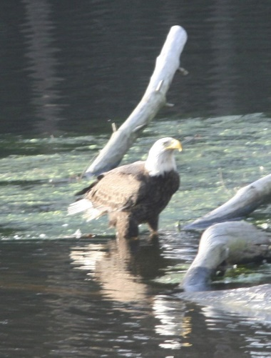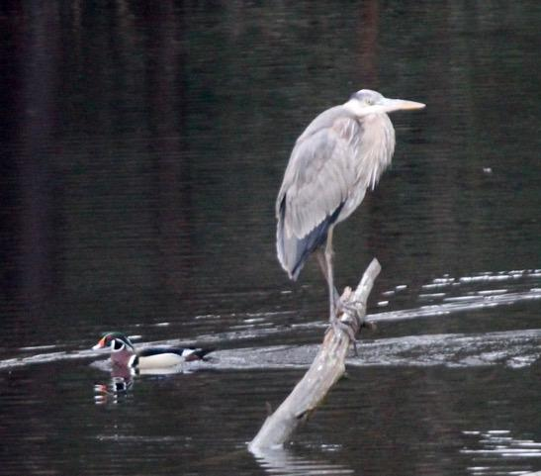

Heron House: Waterfront Two Ways

First is your 420 feet on the 6 acre fresh water pond. Perfect for birdwatching.

BIRDS: Herons of course, plus eagles, ospreys egrets, Canada Geese, Wood Ducks, Mallards, Black Ducks, Hooded Mergansers, Pintail, Scaup, Blue-winged Teal, plus a bevy of song birds: Carolina Wrens, Chipping Sparrows, Juncoes, Robins, Chickadees, Woodpeckers, Cowbirds, and Blackbirds. Sit in the sunroom or on the outside deck with your binoculars and camera at the ready.

CRITTERS: White-tail deer come to drink, Raccoons, Opossums, Muskrats, I think we saw an Otter one time, rabbits.

Heron House: Waterfront for Boating

Kayaking in the pond of course and one block away, if there was a block, is the community dock. Depth of water is 4 feet MLW at mooring and 5 feet at end. You are welcome to keep your boat there as long as you like.

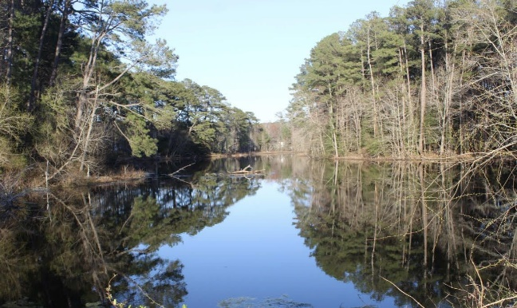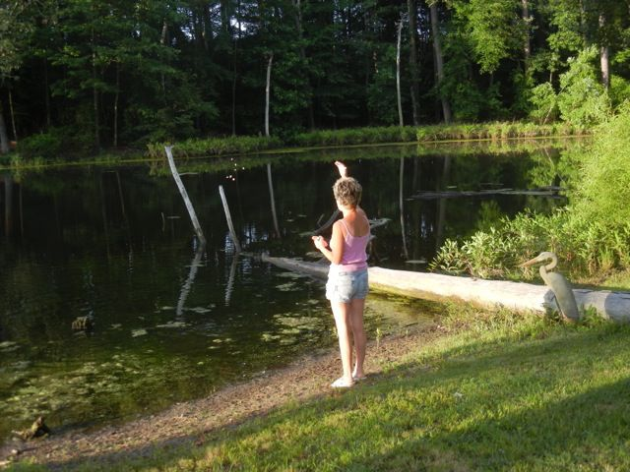

FISH: In pond: largemouth bass and perch. In creek and bay: Crabs, oysters, striper, croaker, rockfish, spot, and some flounder.

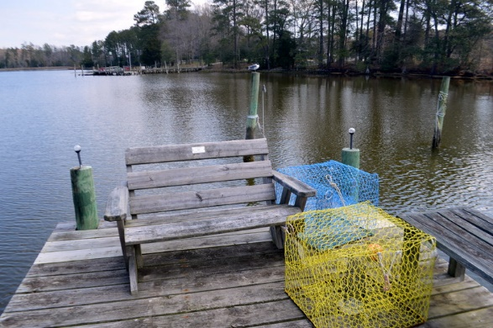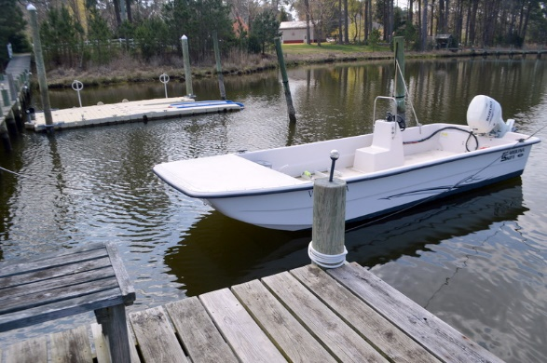

Heron House is very much a contradiction of old and new with two kinds of waterfront and all kinds of wonderful. “Must see to appreciate” is such a cliché but this time it’s true.

